

In His Name

Quiz 1

Arrays and Functions

19 /12/ 1397

# Be Aware : you are **not** allowed to use any libraries except **stdio.h** .

1 - Write a program that gets two numbers from the user ( as input , not hard coded ) and then returns the summation of those two numbers and prints them using printf() .

Be Aware : the input can be negative and can have floating points . **(50%)**

**#** you shall not use any kinds of array .

**EX :**

>> Please enter 1st Number :

>> 12.59

>> Please enter 2nd Number :

>> **-** 6.59

>> The Summation would be : 6

2 - Write a function that gets an integer array ( hardcoded ) and calculates the variance of the existing data in the array .**(50%)**

( the prototype of the function is Up To You . Choose the suitable prototype )

You have to write the power function by yourselves .

Variance formula :

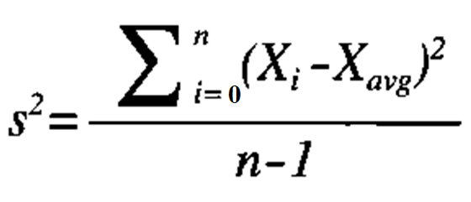

* Bonus : if you can calculate ‘s’ without using math.h , you will get extra score . (**25%**)